Name:Yash Shah

UID: 2018130049

Batch D, TE Comps

CEL 51, DCCN, Monsoon 2020

Lab 6: Subnet and Router Configuration

## Topology Diagram

## 

## Addressing Table

|  |  |  |  |  |
| --- | --- | --- | --- | --- |
| **Device** | **Interface** | **IP Address** | **Subnet Mask** | **Default Gateway** |
| **R1** | **Fa0/0** | 192.168.1.65 | 255.255.255.192 | **N/A** |
| **S0/0/0** | 192.168.1.129 | 255.255.255.192 | **N/A** |
| **R2** | **Fa0/0** | 192.168.1.193 | 255.255.255.192 | **N/A** |
| **S0/0/0** | 192.168.1.190 | 255.255.255.192 | **N/A** |
| **PC1** | **NIC** | 192.168.1.126 | 255.255.255.192 | 192.168.1.65 |
| **PC2** | **NIC** | 192.168.1.254 | 255.255.255.192 | 192.168.1.193 |

## Learning Objectives

Upon completion of this lab, you will be able to:

* Subnet an address space given requirements.
* Assign appropriate addresses to interfaces and document.
* Configure and activate Serial and FastEthernet interfaces.
* Test and verify configurations.
* Reflect upon and document the network implementation.

## Scenario

In this lab activity, you will design and apply an IP addressing scheme for the topology shown in the Topology Diagram. You will be given one address block that you must subnet to provide a logical addressing scheme for the network. The routers will then be ready for interface address configuration according to your IP addressing scheme. When the configuration is complete, verify that the network is working properly.

**Task 1: Subnet the Address Space.**

**Step 1: Examine the network requirements.**

You have been given the 192.168.1.0/24 address space to use in your network design. The network consists of the following segments:

* The network connected to router R1 will require enough IP addresses to support 15 hosts.
* The network connected to router R2 will require enough IP addresses to support 30 hosts.
* The link between router R1 and router R2 will require IP addresses at each end of the link.

**Step 2: Consider the following questions when creating your network design.**

How many subnets are needed for this network? **3**

**Ans) 3 subnets will be needed as three networks are formed**

What is the subnet mask for this network in dotted decimal format? **255.255.255.192**

**Ans) 192.168.1.0/24 is a Class C network because the first octet 192 falls in the class C network range. Class C network has a default subnet mask of 1111111.11111111.11111111.0. Since first three octets are dedicated to network and they can never be change. Since 3 subnet bits, hence there will be (2n>3, therefore n=2) 2 1s in the final octet. So, the binary form of the subnet mask is 11111111.11111111.11111111.1100000**

**The subnet mask is 255.255.255.192**

What is the subnet mask for the network in slash format? **/26**

**Ans) It is the total number of ones in the binary form of the subnet mask. So, the subnet mask in slash format is /26**

How many usable hosts are there per subnet? **62**

**Ans) Using the hosts formula, Usable hosts = 2h - 2 = 26- 2 = 62 hosts**

**Step 3: Assign sub-network addresses to the Topology Diagram.**

1. Assign subnet 1 to the network attached to R1.
2. Assign subnet 2 to the link between R1 and R2.
3. Assign subnet 3 to the network attached to R2.

**Task 2: Determine Interface Addresses.**

**Step 1: Assign appropriate addresses to the device interfaces.**

1. Assign the first valid host address in subnet 1 to the LAN interface on R1.

**192.168.1.65**

1. Assign the last valid host address in subnet 1 to PC1.

**192.168.1.126**

1. Assign the first valid host address in subnet 2 to the WAN interface on R1.

**192.168.1.129**

1. Assign the last valid host address in subnet 2 to the WAN interface on R2.

**192.168.1.190**

1. Assign the first valid host address in subnet 3 to the LAN interface of R2.

**192.168.1.193**

1. Assign the last valid host address in subnet 3 to PC2.

**192.168.1.254**

**Step 2: Document the addresses to be used in the table provided under the Topology Diagram.**

**Task 3: Configure the Serial and FastEthernet Addresses.**

**Step 1: Configure the router interfaces.**

Configure the interfaces on the R1 and R2 routers with the IP addresses from your network design. Please note, to complete the activity in Packet Tracer you will be using the Config Tab. When you have finished, be sure to save the running configuration to the NVRAM of the router.

Network devices

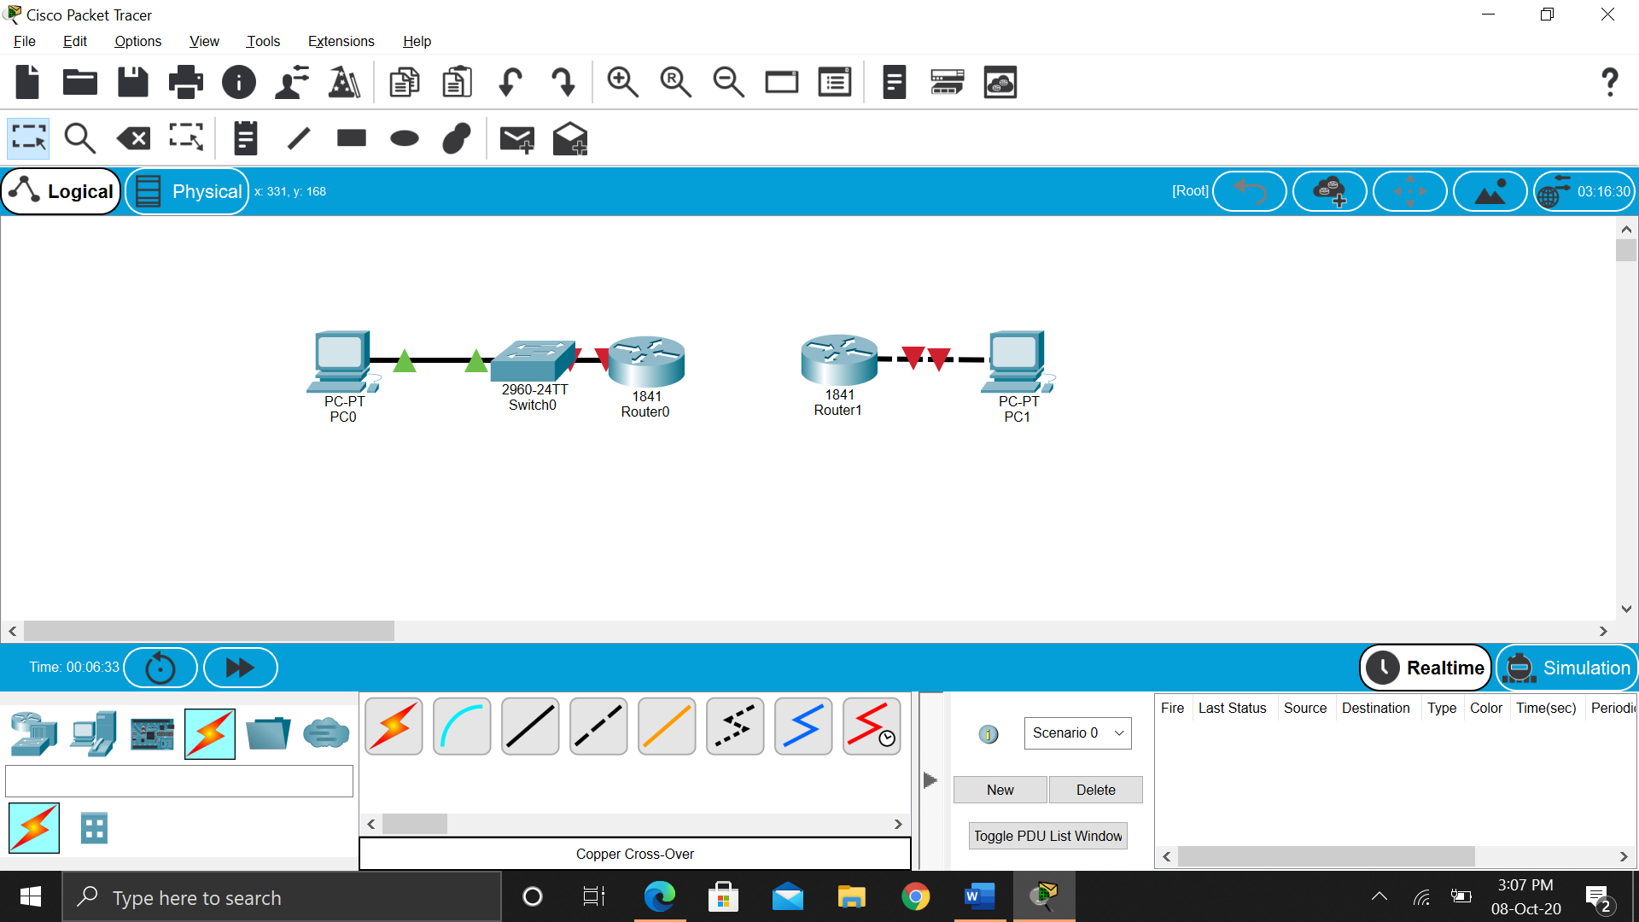

Adding Serial Ports to Routers

1. Turn Router off in Physical Tab of Router0

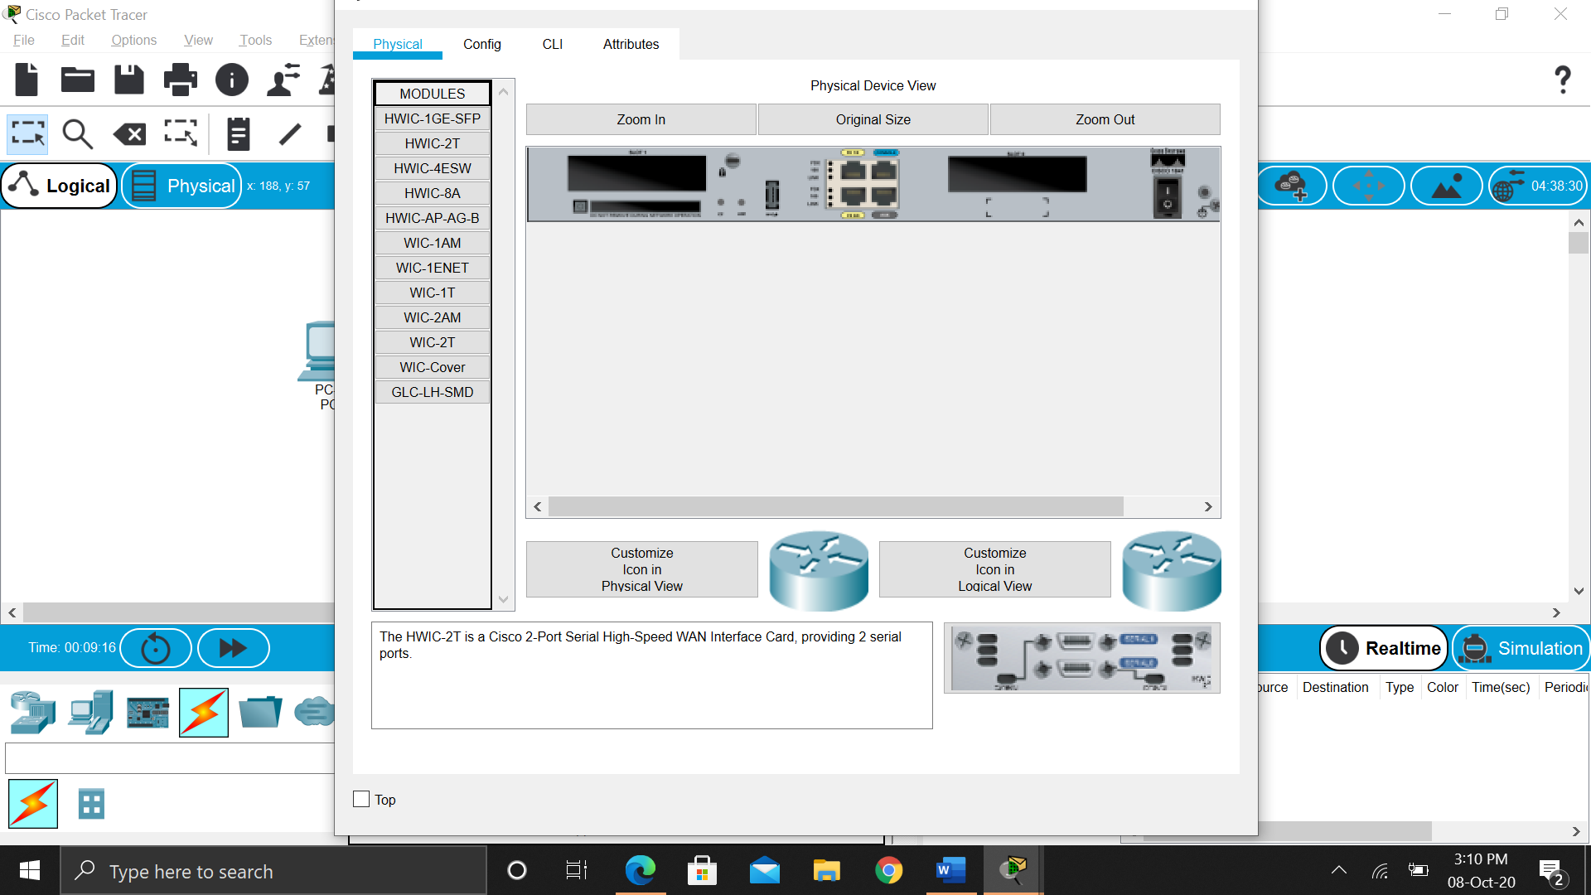

1. Click on HWIC-2T tab and drag Cisco HWIC-2T 2-Port Serial WAN Interface Card to router then turn router on

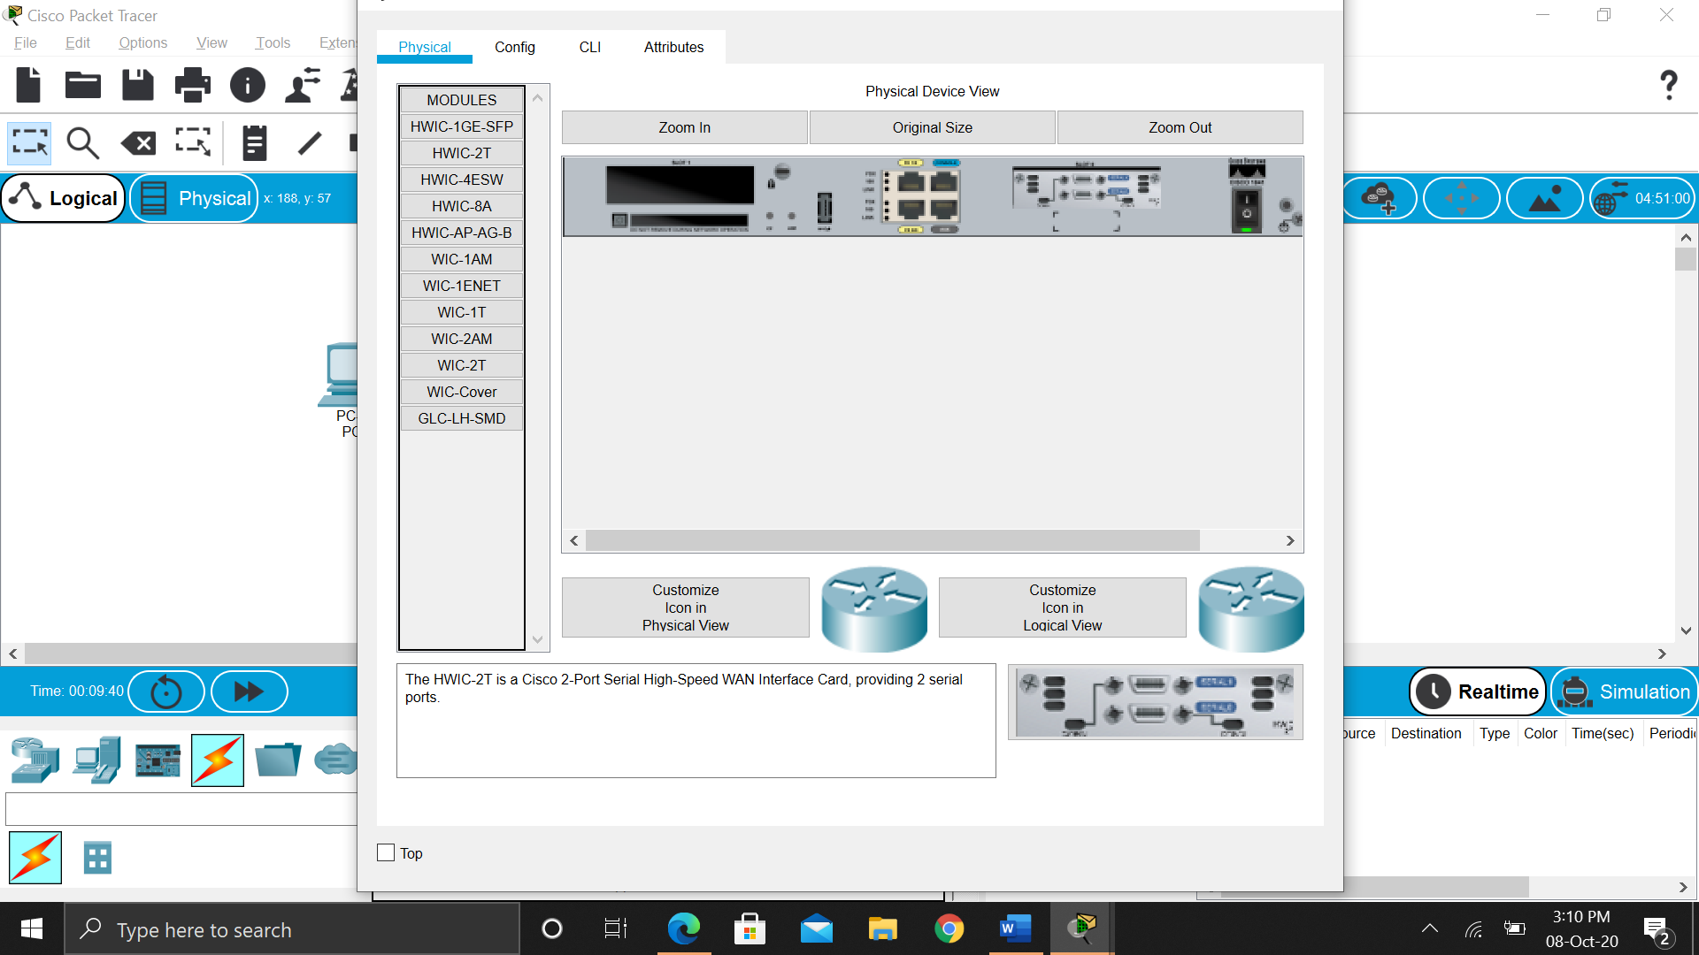

Similarly, 2 serial ports are added to Router1

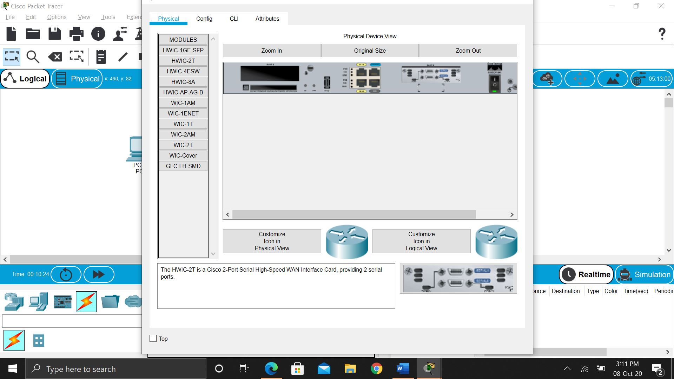

Now, we can connect R1 and R2 using DTE

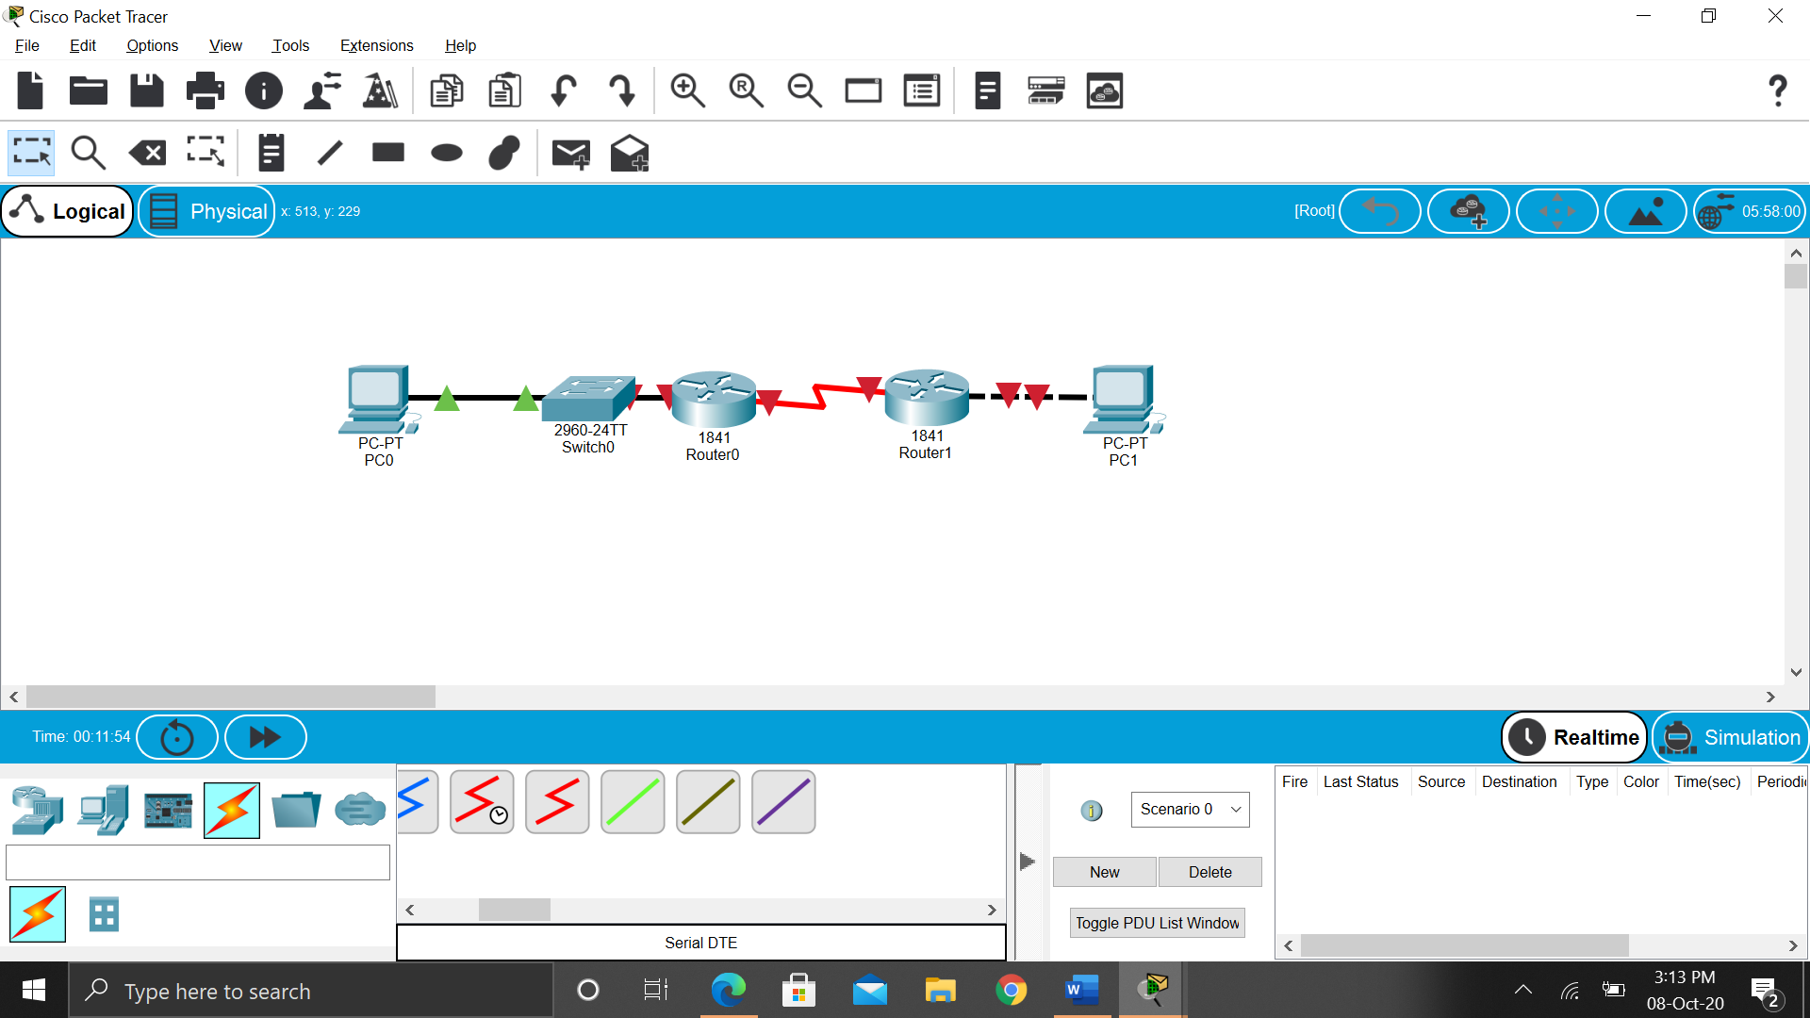

**Router Configuration**

Interface Fa0/0 of Router0

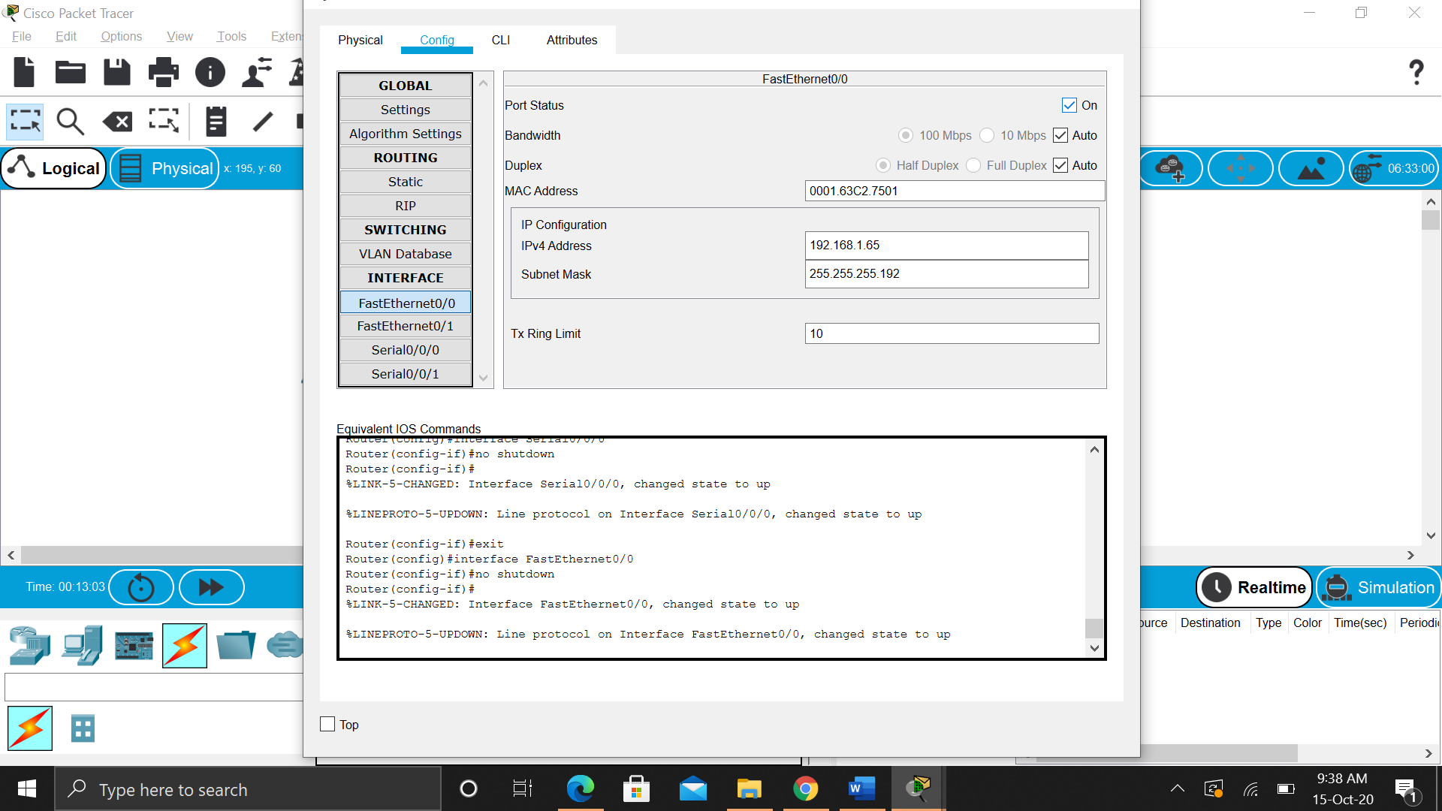

Interface S0/0/0 of Router0

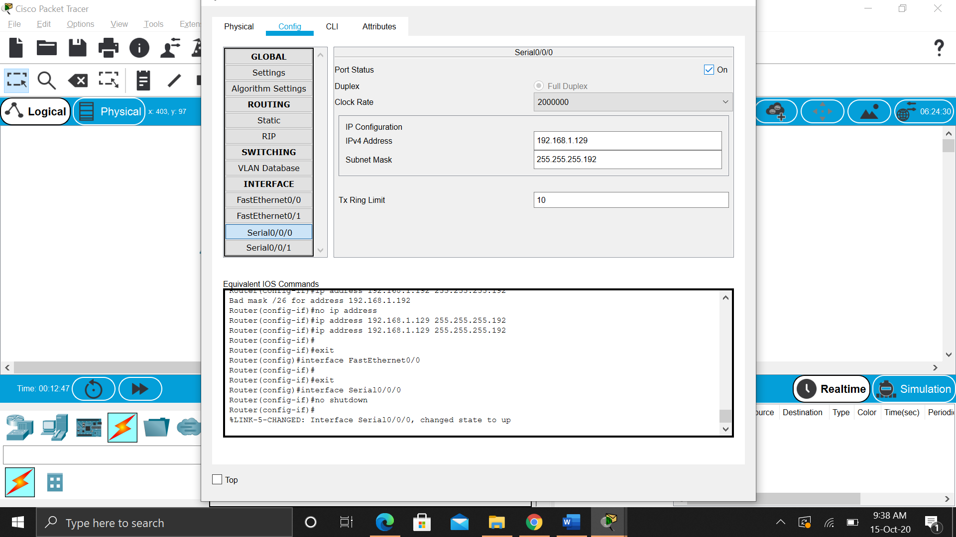

Interface Fa0/0 of Router1

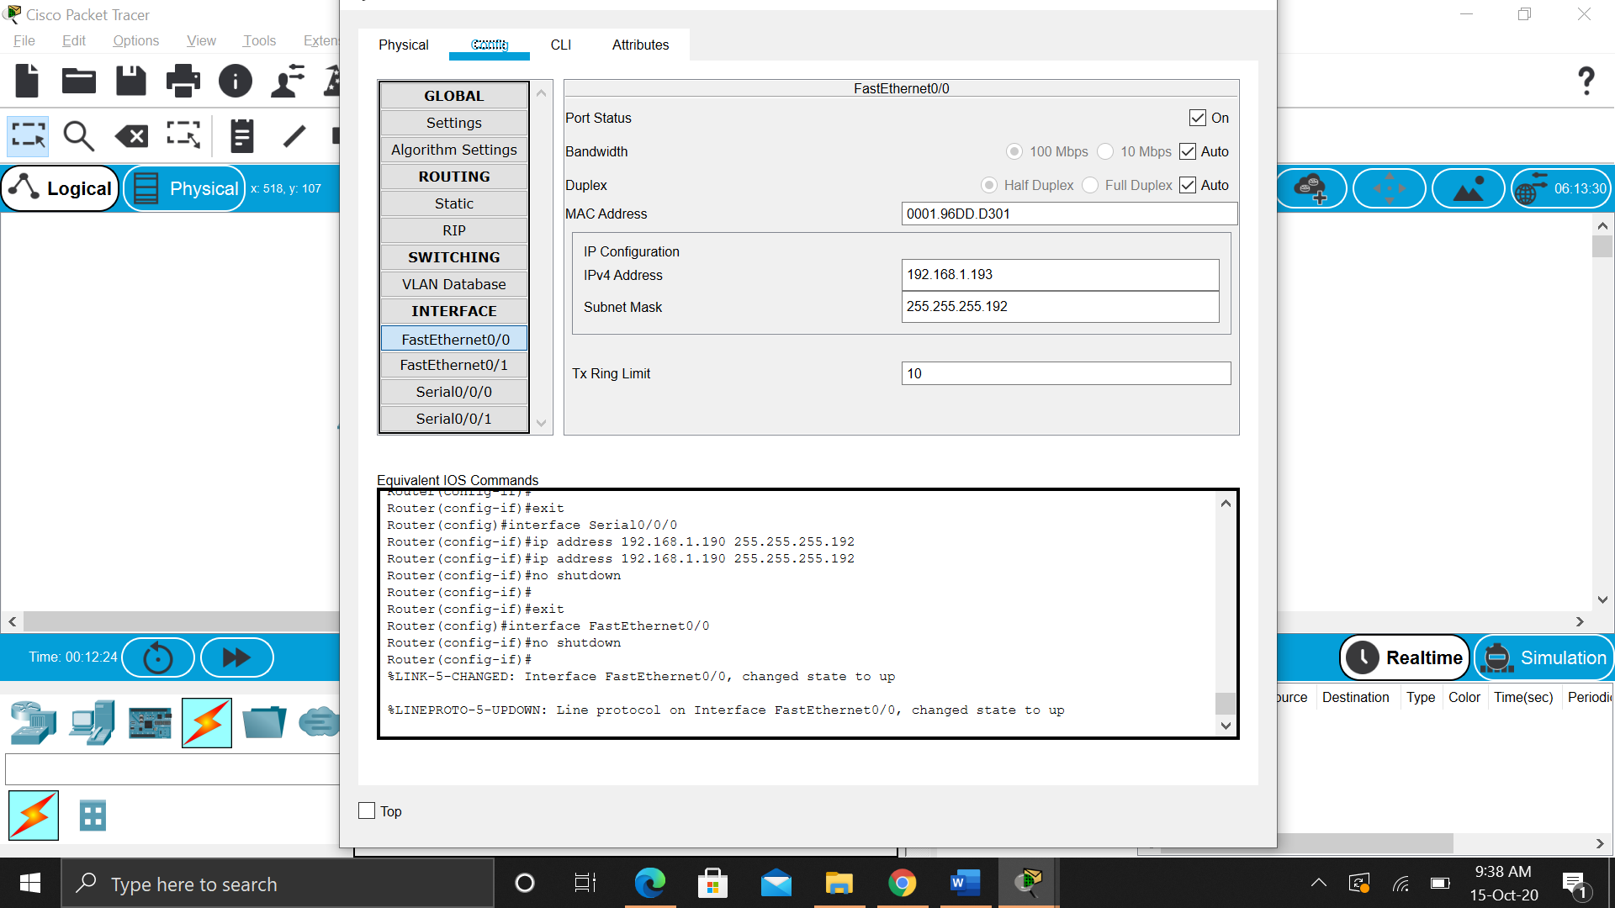

Interface S0/0/0 of Router1

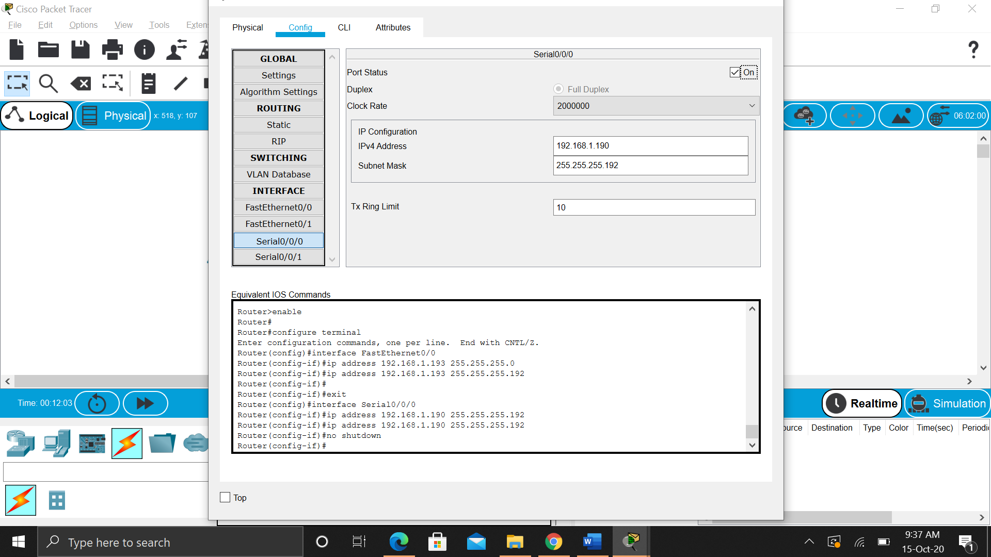

**Step 2: Configure the PC interfaces.**

Configure the Ethernet interfaces of PC1 and PC2 with the IP addresses and default gateways from your network design.

Interface Fa0/0 of PC0

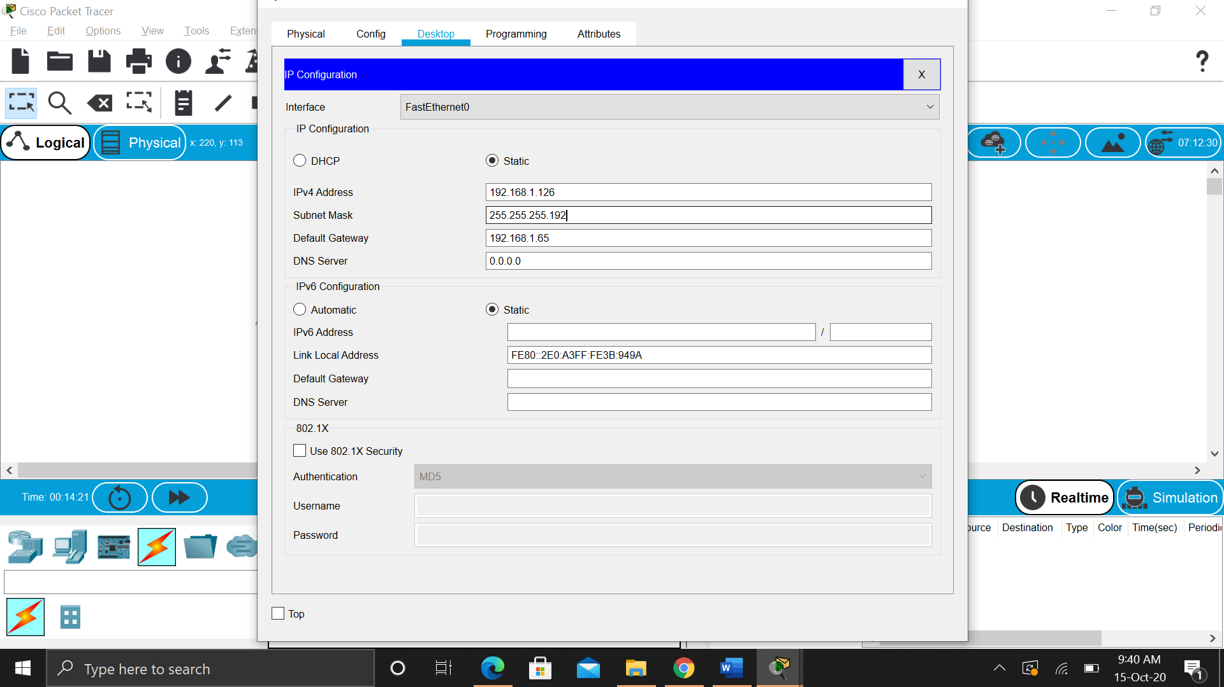

Interface Fa0/0 of PC1

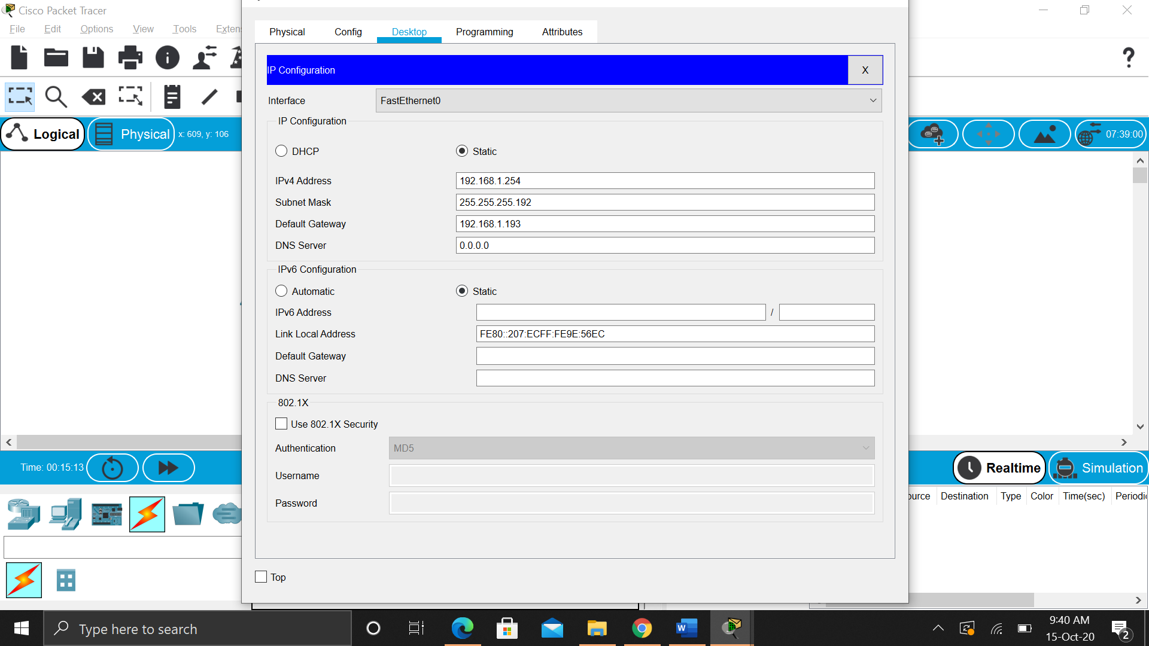

Final Network

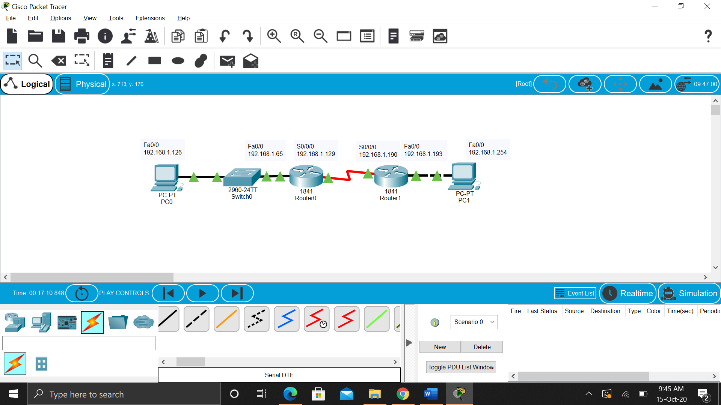

Initially, the routers have no startup-config

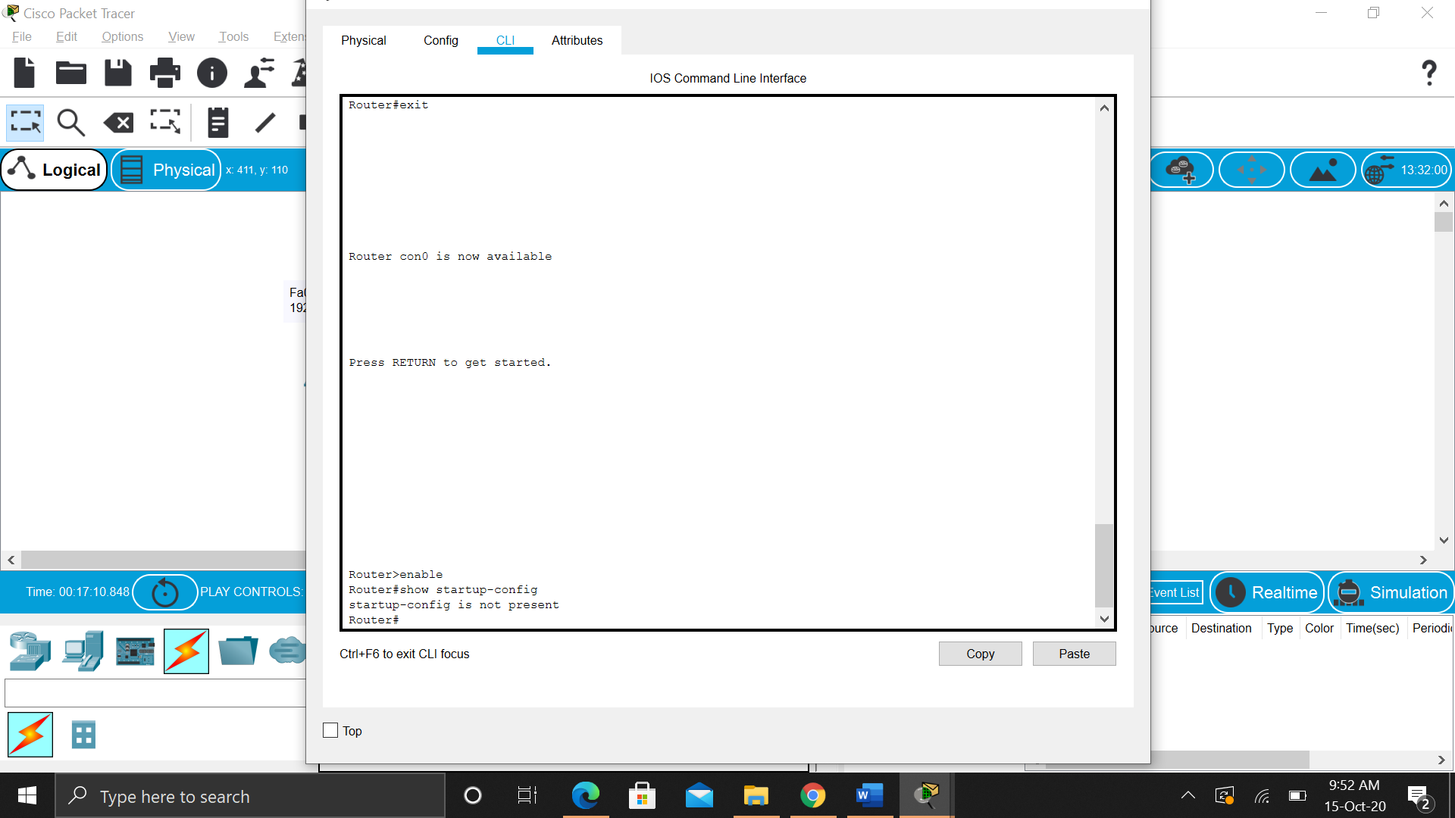

Saving running-config as startup-config

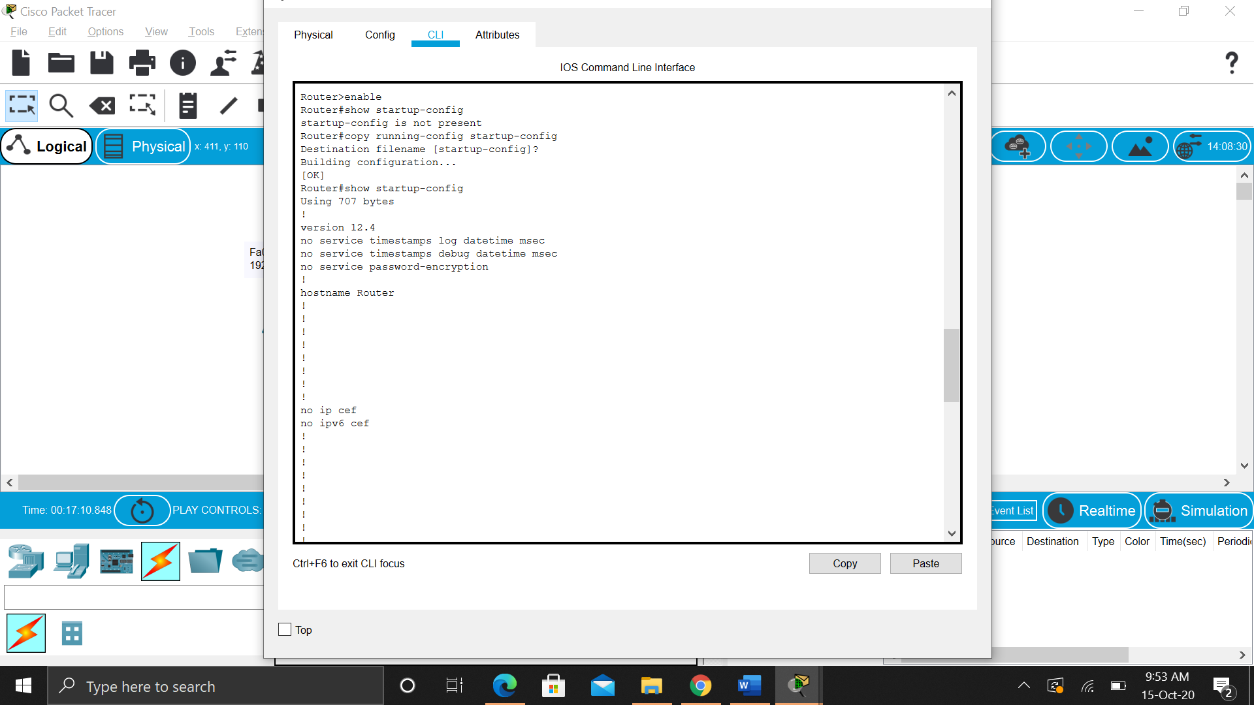

Router0

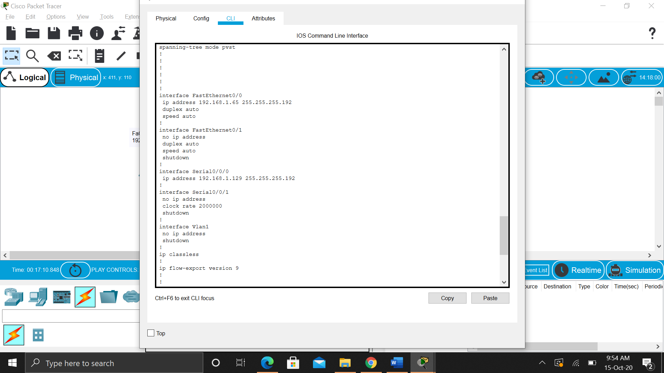

Router1

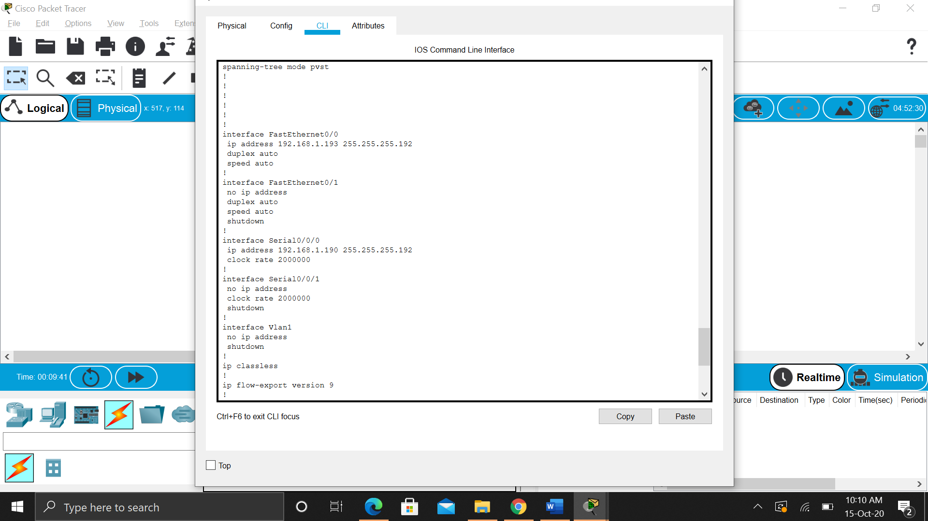

**Task 4: Verify the Configurations.**

Answer the following questions to verify that the network is operating as expected.

From the host attached to R1, is it possible to ping the default gateway? **Yes**

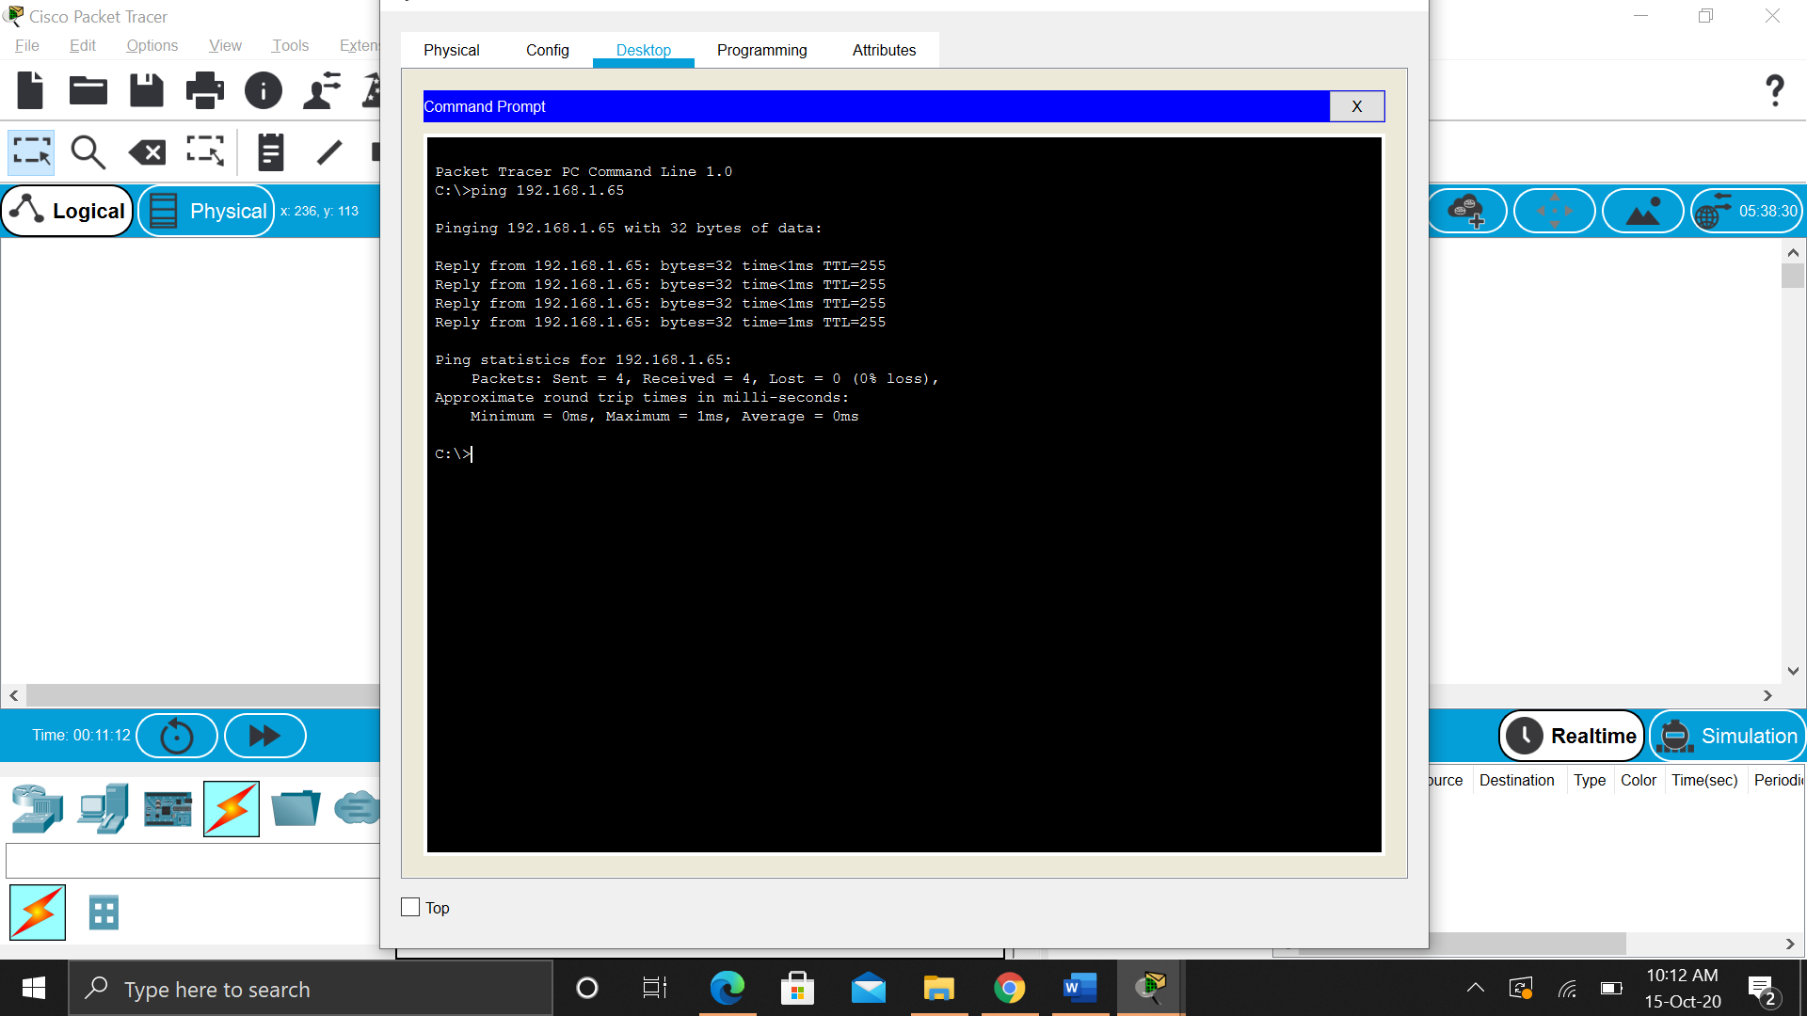

From the host attached to R2, is it possible to ping the default gateway? **Yes**

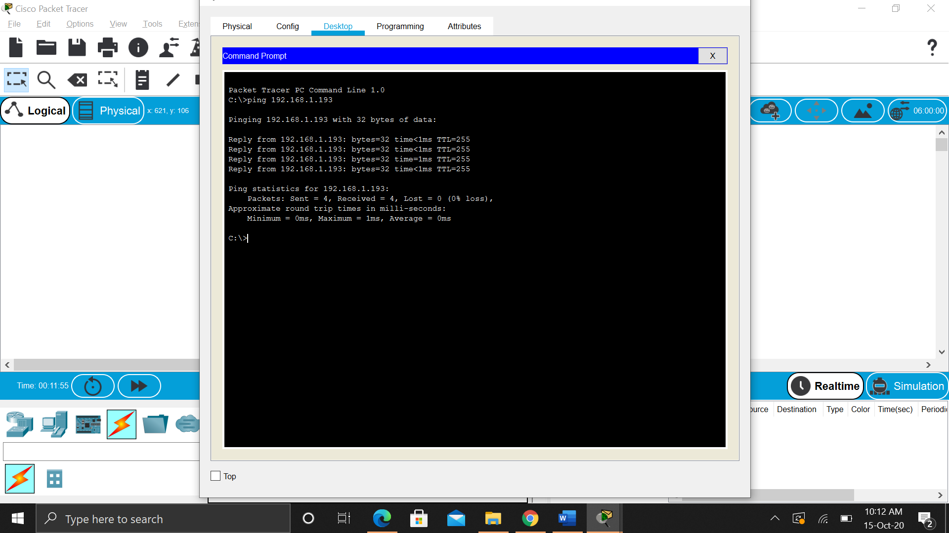

From the router R1, is it possible to ping the Serial 0/0/0 interface of R2? **Yes**

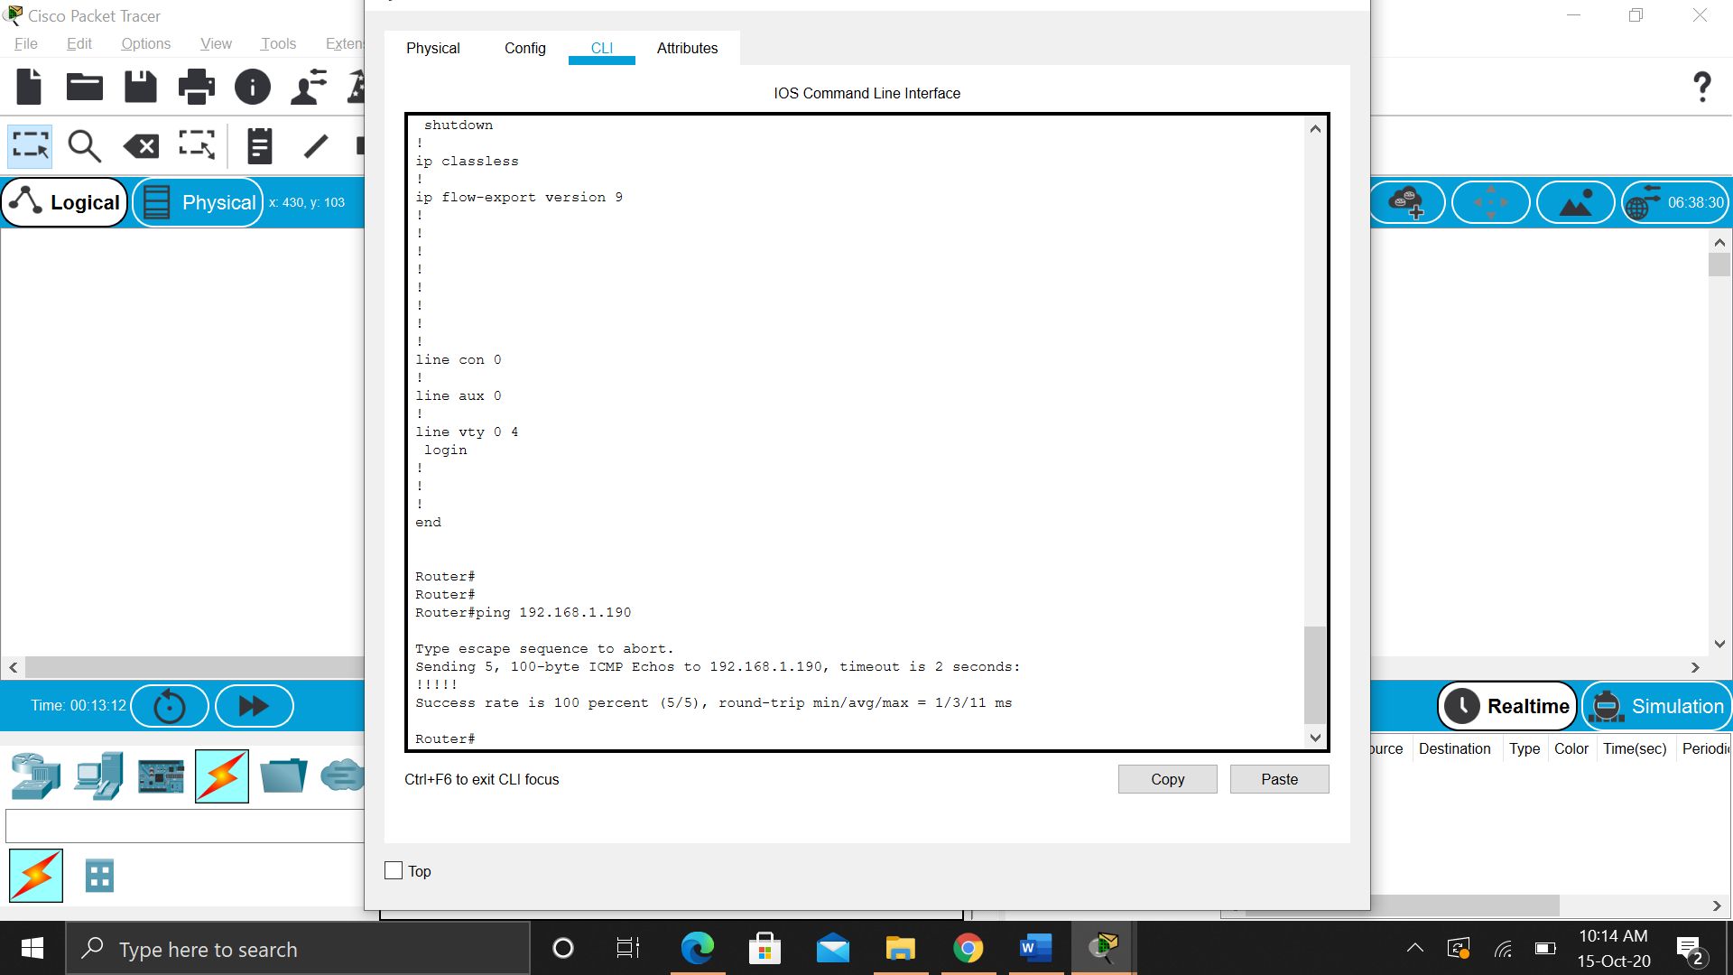

From the router R2, is it possible to ping the Serial 0/0/0 interface of R1? **Yes**

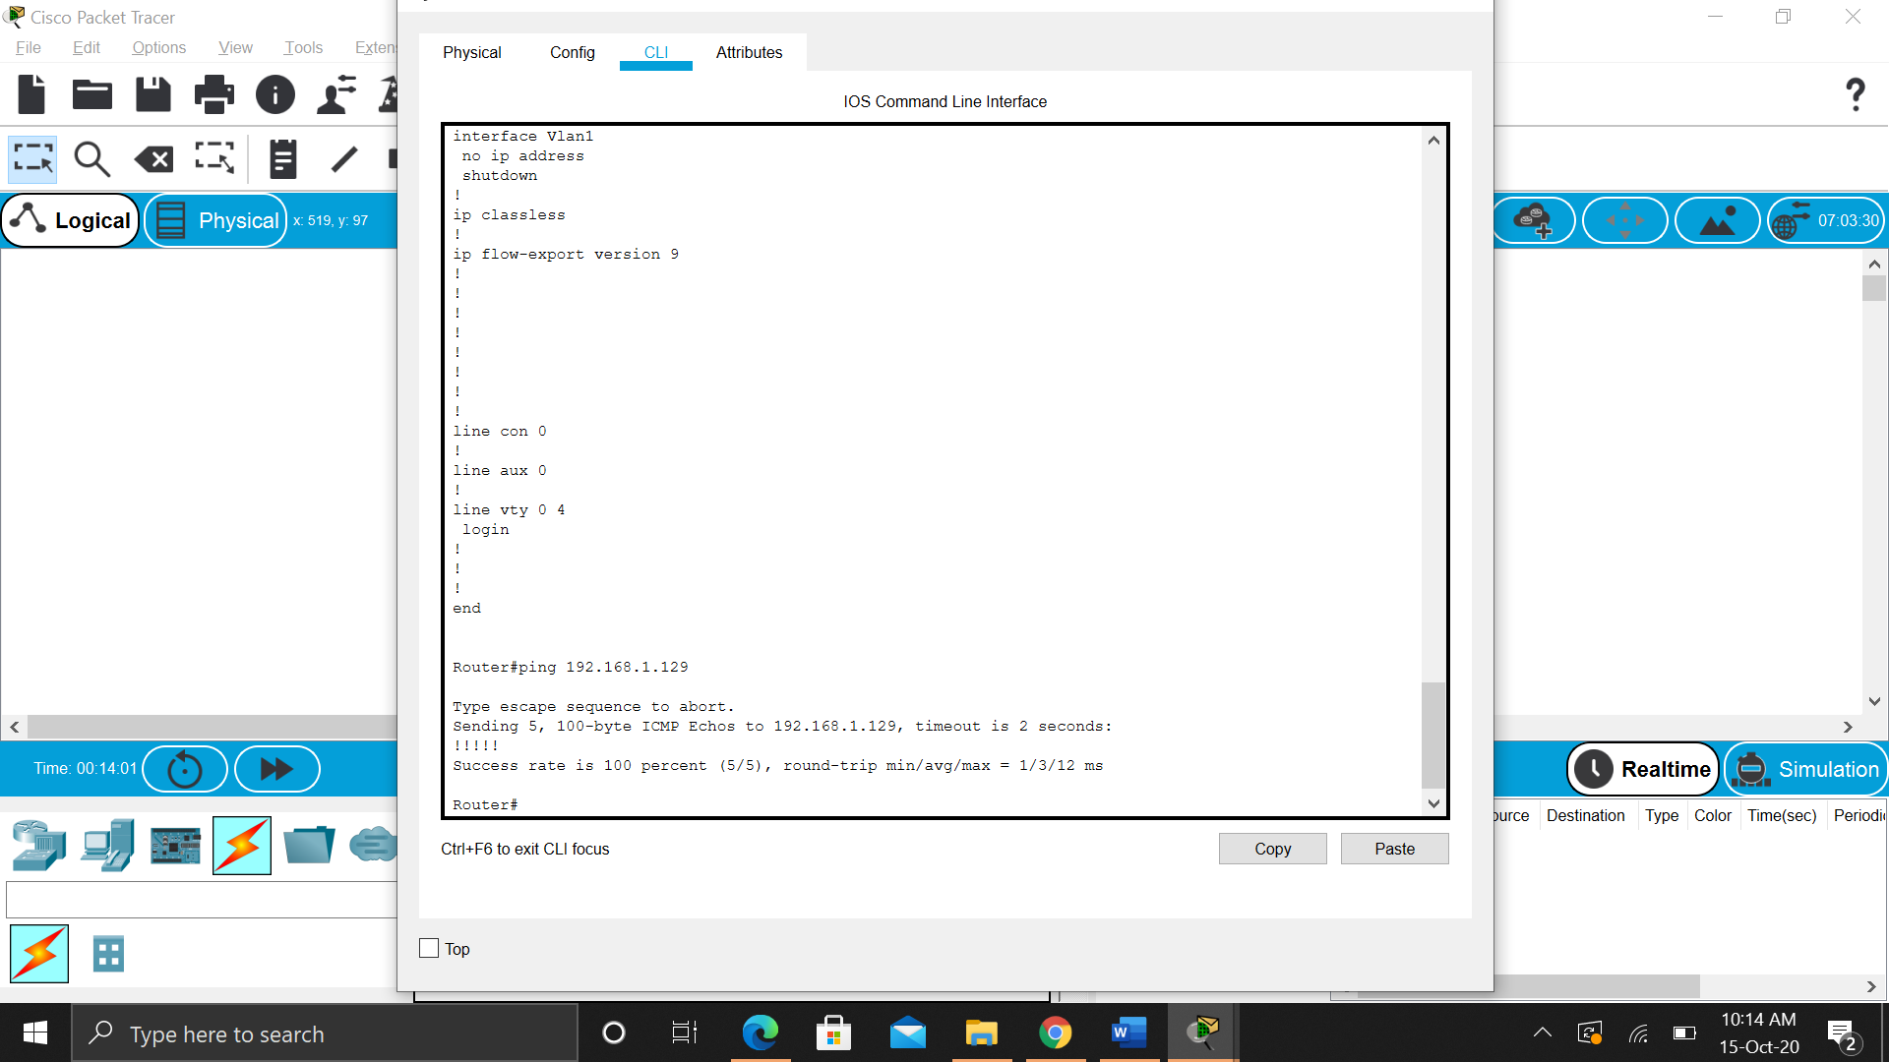

The answer to the above questions should be **yes**. If any of the above pings failed, check your physical connections and configurations.

**Task 5: Reflection**

Are there any devices on the network that cannot ping each other?

**Yes, devices that are not a part of the same network cannot ping each other. For example, PC1 and PC2 cannot ping each other**

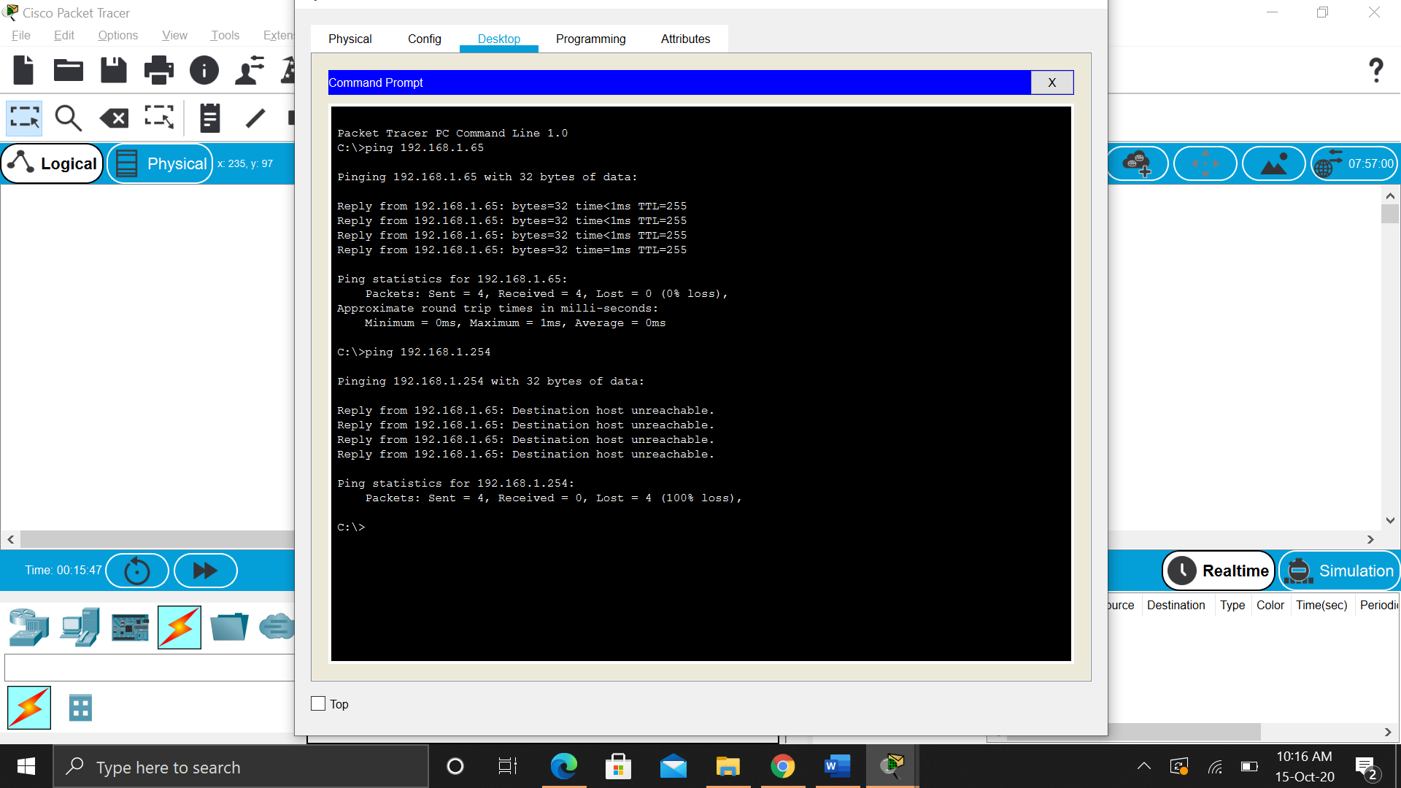

What is missing from the network that is preventing communication between these devices?

**Switch is missing**